What is mule soft?

Mule soft is a middleware technology to integrate 2 different applications, Mule is just a pass through

Whatever java as backend can do, with mule also we can achieve it especially for integrations

It is fully a drag and drop and we don’t need to write any code,

1. From mule designs we can call java class static and instance methods
2. Our mule can call a soap web service
3. Our mule can call a RESTful web service
4. Our mule have schedulers –all are just drag and drop, it have caching services
5. It can integrate with kafka, it can connect with MQ
6. It have inbuilt load balancer

Let say u want to develop an application which should consume a web service

1. It can hit AWS also
2. It has database connectors to connect to database, we can execute CRUD operations, call stored proc’s
3. Here we can create controllers to accept our request, it will hit the db and get the data or it can call REST/SOAP svc
4. Here we can configure rate limiters, in 1 hour only 10 requests my api should receive, remaining It should reject

Ex:- kafka is acting like a middle ware used to integrate 2 applications, like web methods ,TIBCO,IBUS

Mule features

Many types of integrations available

1. A2A- Appn to appn integration
2. B2B – business to buiness

Mule is a light weight java based ESB (enterprise service bus), runtime engine of any-point platform & integration platform

Allows developers to connect to appns quickly

Using this

1. We can design our api’s (but generally we can design using REST/SOAP na?)-if we design using mule who will consume it
2. If u want to talk to a web service, then talk via mule api.
3. Based on the message content, we can route the incoming message to another appn- based on the header we can route
4. We can do message transformations- if source sys send in xml, mule can transform to json and send it
5. If u want to talk to database also, we can go via mule, it has inbuilt adapters, transformers to transform data acc to target systems(for this we already have jdbc, not sure why we need mule still)

Components of mule

1. Runtime plane
2. Control plane
3. Design center- is like IDE to create our own apis-like soap or REST api’s
4. Anypoint exchange- is like a market place for connectors, templates, examples, api’s-where other persons can use

We can share our assets(which are all mentioned above) here

1. Runtime manager- to deploy our apns
2. API Manager- to secure our api’s –we can create api’s, if some apis are already existing and hosted somewhere, just import those WSDL api’s .

Anypoint studio is like a IDE to create mule projects (here u can use drag and drop also)

Terminologies

1. Here Data weave is the expression language

**How we will access the properly value in dataweave expression language**

p(‘<propertyname>') – to access the property from configuration

p(‘secure::<propertyname>') – to access the property from configuration

Download mulesoft

Google🡪 download mule and anypoint studio (mule anypoint studio download)

Create a project

1. Just in studio , give project name and click finish & it will be created as below

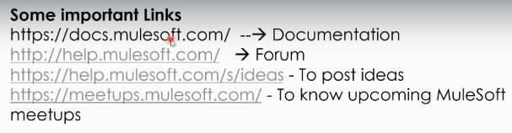

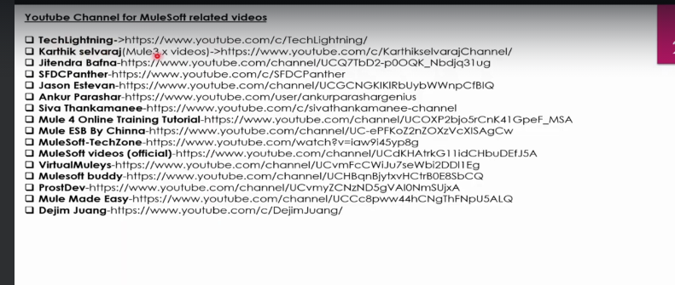

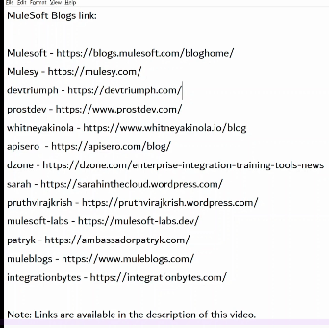

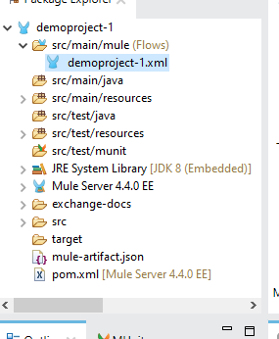

Terminologies

Remember payload means from postman while sending POST request, it is the json object we send

Attributes nothing but, we will send them in URL

Vpc –means virtual private cloud

We will deploy java code in jvm, similarly we will deploy mule code in mule runtime engine

DLB- dedicated load balancer

SLB-shared load balancer

Vpc- virtual private cloud

On premise is nothing but customer hosted environment

Points to note down

Every application must be in isolated environment

No 2 applications should not share same , if u deploy all apps in same HDD without dedicated RAM then other app may consume more , and u cannot tell which app consumed more memory that’s why all apps should run in isolation

Modules

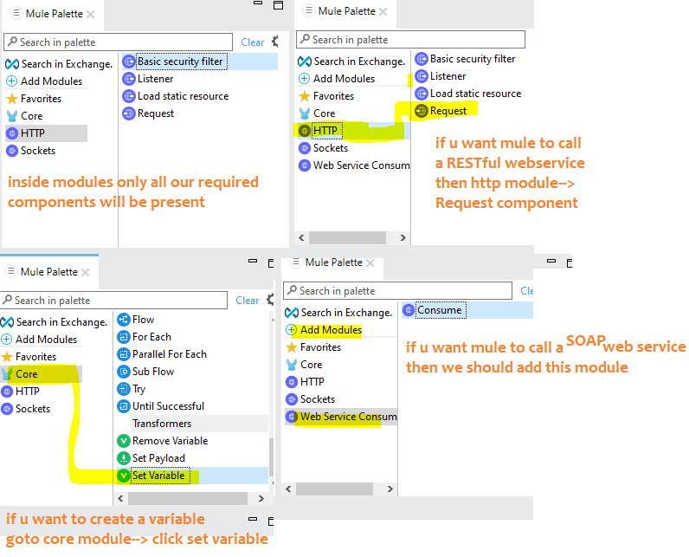

Why Mule

Lets say 10 projects are using oracle database,

Tomorrow if we want to migrate from oracle to mongo, then all 10 systems needs code change,

whereas if all 10 systems connects to mule, and mule will connect to oracle, if change comes only we need to change in mule

so mule says use me as middle ware, and mule says avoid point to point communication,

Programs

1. Create a program with listener, logger, create a variable, & add a logger to print that log statement
2. Here listener is nothing but a controller

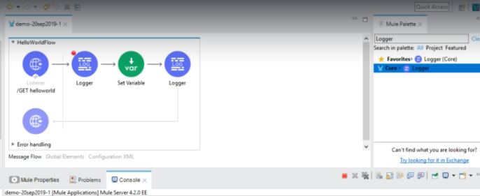

Full code available below

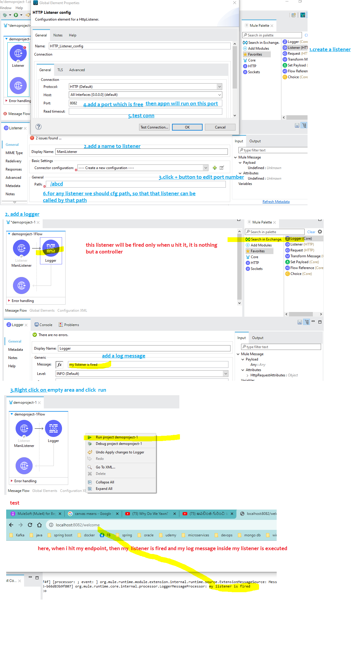

Components

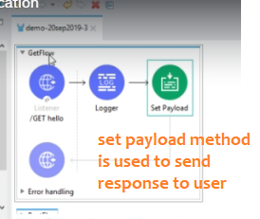

Invoking a REST web service from mule soft

**the main purpose of this is, if u hit mule, it will hit target REST svc and get the response, it is just a middleware**



Main flow vs subflow

Main flow can have a source/ listener and it will have exception handling

Where sub flow doesn’t have exception handling, it doesn’t have source and it can only be invoked from main flow

Try catch blocks

Same like java here also we have try catch blocks, here also we have components to propagate exceptions

& we can catch exceptions all java things are possible here

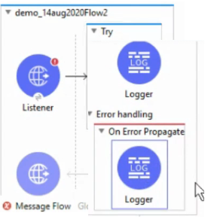

Scheduler in mule

U can create a scheduler with cron expression, like every ten minutes and every day 8AM all…

, it will run and do some jobs like Printing a log

Invoking a SOAP web service from mule soft

For this we have to add a new module called webservice in mulesoft studio

Here is the dummy soap WSDL file

http://www.dneonline.com/calculator.asmx?wsdl

here first listener (nothing but controller) is mandatory

Because, if u hit controller, then it will hit the soap web service

Complete step by step example is available here



Sub-flow, private flow

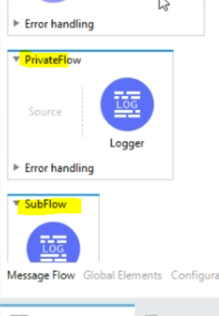if the flow doesn’t have any source (like listener), then it can not be invoked externally

those kind of flow is called private flow

The main difference between sub-flow and private flow is subflow doesn’t have error handling

==========================================

If any exception occurred in sub-flow it will be cascaded to main flow,

From flow reference only we can call either sub flow or main flow

Why this private flow or sub-flow what is the use of it

===========

These flows are similar to private methods in java, these are for re-usability purpose

These private methods should be called by main method, similarly these sub flows or private flows can be called only by a flow reference

Publish subscribe –vm connector

This is used when u wan to use vms and when we want to use queues,

There are 2 types of queues

1. Transient- messages wont be stored in HDD, it might be stored in RAM so it is faster, but once queue is restarted messages are gone, because they are stored in RAM not HDD
2. Persistent queue- these messages will be stored in HDD, hence bit slower than transient



Move the files



Monitor a certain folder then continuously check if file came , then move to another folder

Scatter and gather

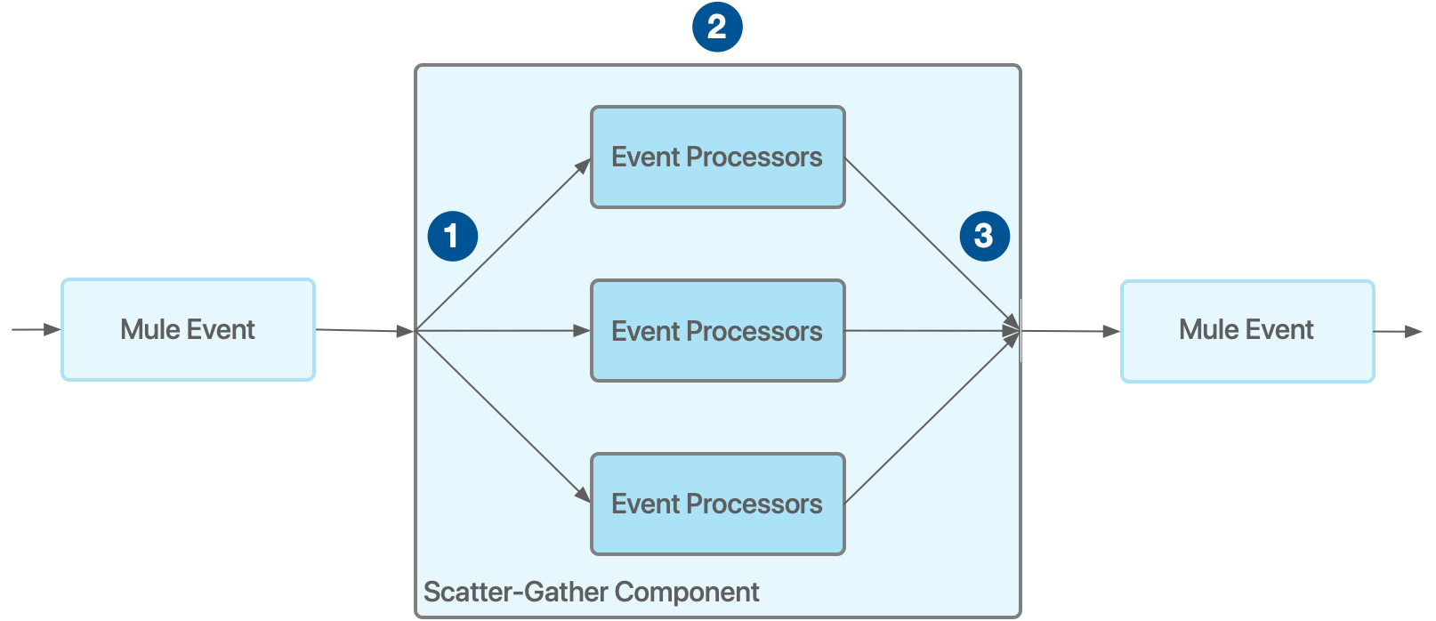

Scatter and gather , - it scatters the mule event to the different routes (each route is handles by separate thread)

and gathers/combines the output from all the threads (paths) only after combining it will move further.

It is like divide and conquer

This is like multi threaded way , where we can achieve it faster way

Scatter and gather component is a routing event processor that processes the incoming mule event through

Multiple parallel routes, whereas each route have a separate event processor,

Each route uses a separate thread to execute the event, each route will give a separate mule event

This scatter and gather component consolidates the mule events generated by all the routes and this component

Will wait for all the routes to complete their execution, it will consolidates all routes output and then it will pass the

Consolidated event to next event processor

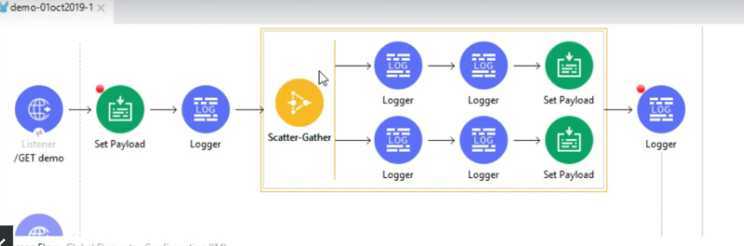

1. In scatter and gather , all the flows will be executed simultaneously by separate threads
2. And the outputs of all the flows will be consolidated and send to next component

Batch processing

In batch processing, same like Kafka how it will take 100 records at once from topic in bulk listen mode, similarly

Here also, single thread will also process 100 records at once, and 16 such threads are present, so in total 1600 records

will be processed at once,

here in below example, we will take an excel file having 1600 records now we will split those records in 1600 files

each record in that csv file will be created as a single file,



Error handling



We have 2 components named “onErrorPropagation” and “onErrorContinue”

In both cases, flow will be terminated but on propagation it will throw error whereas oncontinue it wont throw error

Object store

Generally we will store data in variables temporarily, but If u want to store those variables to disk (so storage is permanent

Not like RAM) then we have to Use some object store, here values will be stored as a map,



Round robin (load balancer)

Its is same like load balancer, when we configure 3 paths, each request will goto only 1 path at a time

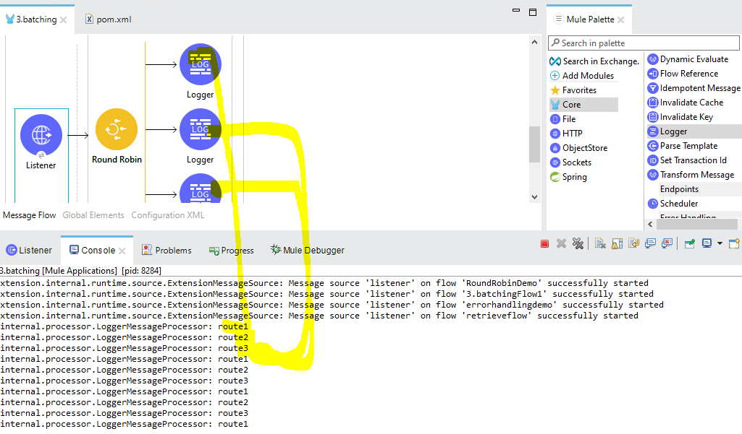

Caching



Parsing Template



Calling java class static, instance method

We can call java static methods from mule, and we can also call instance methods from mule palette



Retry/until successful **Scope**

This is nothing but retry in our spring,

We can set maximum retry attempts as 5 for an interval like, if first retry failed then it will wait for 5 seconds and then it will

Try a second attempt, similarly we can configure as many attempts as our wish



Send an email

If u hit mule via mule controller, mule will send an email using component called emailSender

Validation

We can happily validate each and every field coming in the payload using below 2 ways

1. Validate entire payload against a schema
2. Validate individual field using validate components

validate the incoming json payload with schema

<https://json-schema.org/learn/miscellaneous-examples.html>

Sample schema

-----------

{

"$id": "https://example.com/person.schema.json",

"$schema": "https://json-schema.org/draft/2020-12/schema",

"title": "Person",

"type": "object",

"properties": {

"firstName": {

"type": "string",

"description": "The person's first name."

},

"lastName": {

"type": "string",

"description": "The person's last name."

},

"age": {

"description": "Age in years which must be equal to or greater than zero.",

"type": "integer",

"minimum": 0

}

}

}

Sample payload

{

"firstName": "John",

"lastName": "Doe",

"age": 21

}

Save the sample schema in json file and if incoming msg is not compliant then automatically exception will be thrown

Kafka

Using this we can connect to kafka also

Securing mule apps

We have to create policies in api manager

JDBC

Transactionally aware connectors –JDBC,vm,JMS

Do –it yourself

Anypoint exchange

This is like market place where all reusable assets are here

Anypoint Exchange is a curated catalog of reusable assets. APIs, API groups, API spec

You can catalog (publish), share, discover, learn about, and reuse assets within your organization to facilitate collaboration, boost productivity, and promote standards.

With exchange we can exchange & publish the assets to the global portal, so that if anybody wants they will consume those API’s , like if I write some kafka integration , if I feel someone can use it , I can publish to exchange

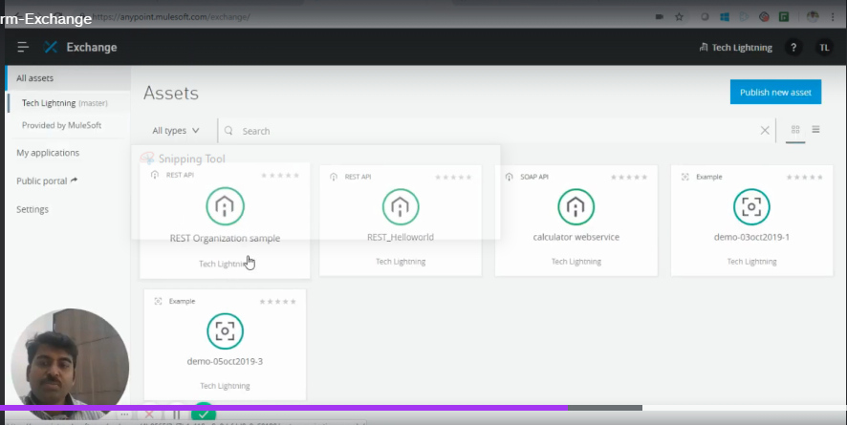

See here he published those api’s , (so if u also did something and u want that svc to be used by all, then publish to exchange)

This is same like when we develop the REST/SOAP web service we will deploy globally so that if anyone wants they will hit and get the response.

So here also , if we publish that other persons will hit and get the response

As per above, it denotes all assets( apis) are published ,if u want u can consume

We can publish our asset from mule anypoint studio itself

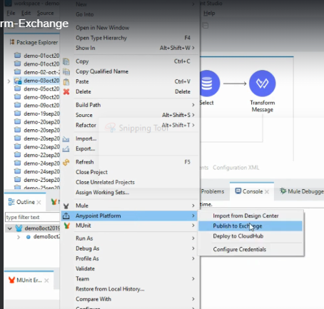

Anypoint design



Designing API’s online instead of developing using IDE

API manager/API Gateway

Let’s say we wrote API, we want only 100 hits per minute, if more hits came if we want to reject all those remaining requests (this is called Rate limiting)

Then we can set this by using an API manager,

Here in mule , when we configure API Manager/API gateway, all the requests first goes via API gateways only



Alerts

Same like alerts which we configure in elastic apm,

We can create many alerts, cpu alert, deployment success, deployment failure, memory usage alerts (like above 90% critical alert)

RAML

RAML is restful api modelling language

RAML is just a specification just like WSDL file, taking that as a reference we can create API’s

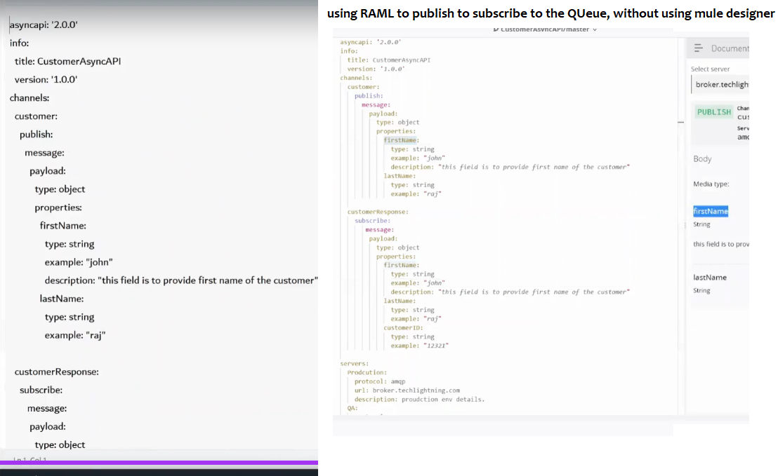

API LED connectivity

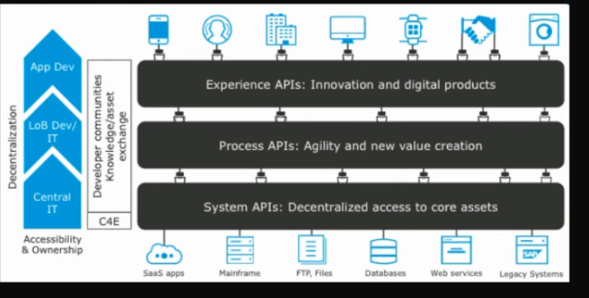

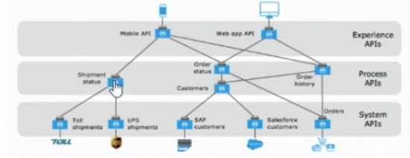

Different stage we have different different api’s

It says expose everything as an api reusable api

Main system apis are different which might give us lot of data, then we should have experience apis which will give

Low data as per the front end like mobile…

Here this says for each and every requirement we should maintain apis

Integration patterns

The most used part in mule is transformations,

**In many cases we can utilize mule as the middle ware**

